Safety Policy Statement

Safety whether during flying of remote aircraft piloted systems (RPAS), training or office-based activities, is a prime consideration and core value within 3iC Ltd at all times. It must be recognised by all, that safety is the responsibility of all persons engaged in aviation activities. Therefore staff whether permanent or temporary, stakeholders or clients, are encouraged to fully engage, and to immediately report any faults or potential hazards however insignificant they may initially consider them to be at the time. It is in pursuing this aim, that a safety culture within 3iC is formed and cultivated.

3iC operates an open and no-blame just culture and strongly encourages open and honest reporting of any issue relating to a potential or real safety incident or hazard. The 3iC open and confidential reporting systems, allow not just its employees, but persons outside of the company to be fully involved in ensuring that we operate in an environment which is as safe as reasonably practicable.

As the Accountable Manager, it is my responsibility to ensure the safety of all company operations and services. This is achieved through the setting of policy, following set process and engendering a committed and engaged response from our employees.

I will ensure that adequate resources and appropriate training are provided to new staff and on-going safety awareness training available for all is provided to manage our collective safety effectively.

Safety Aims – At 3iC, we strive to achieve:

- An effective safety management system with continuous improvement measures and a fully engaged safety focused workforce
- Full compliance with the statutory National and International regulations that apply to our business activities
- A safe working environment where potential operating hazards are first identified and then managed as low as reasonably practicable

These aims are for the benefit of the company, employees, customers and those others engaged with 3iC. To achieve this end, we share the same responsibility.

This Safety Management System is an organised approach to managing safety and sets out the responsibilities and hazard identification reporting and mitigation processes. This document is pre-requisite reading for all 3iC employees and contractors. It is to be read as part of the company induction process. All personnel are actively encouraged to suggest improvements to this system.

Signed by 3iC Ltd Accountable Manager

Signature:
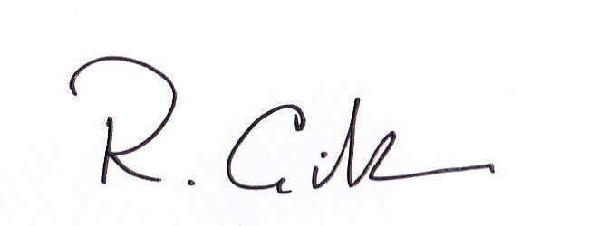
R Gillan

